CSC-203L Computer Network
Assignment Documentation
Chat Application

Submitted by:
Abdul Moez 2024-SE-14
Umair Arshad 2024-SE-38
M. Zeeshan 2024-SE-13
Submitted to:
Sir Nouman
Dated: 28th NOV 2025

Department of Computer Science
University of Engineering and Technology Lahore, New Campus

Table of Contents
Overview 3
Architecture 3
Features 3
Installation & Setup 4
Running the Application 4
Configuration 4
Protocol Details 4
Text Messages 4
File Transfers 4
Voice Call Signaling 4
Room Management 5
Client Interface 5
Main Menu Options 5
Technical Specifications 5
Network Configuration 5
Audio Settings 5
File Handling 6
Error Handling 6
Connection Issues 6
File Transfer Reliability 6
Limitations & Known Issues 6
Extension Possibilities 6
Conclusion 7

Overview
A feature-rich peer-to-peer chat application with real-time messaging, file sharing, and voice calling capabilities. The application uses TCP for reliable communication and UDP for real-time audio streaming.

Architecture
- Server: Central message router and session manager
- Client: User interface with multiple communication features
- Protocol: Hybrid TCP/UDP system
  - TCP: Text messages, file transfers, signaling
  - UDP: Real-time audio streaming for voice calls

Features
1. Real-time Messaging
- Broadcast Messages: Send messages to all connected users
- Private Messages: One-to-one private conversations
- Room-based Chat: Create/join chat rooms for group discussions
2. File Sharing
- Send files to individual users, rooms, or all users
- Automatic file chunking and reassembly
- Dedicated download directory ("Downloads")
3. Voice Calling
- Peer-to-peer audio calls using UDP
- Real-time audio streaming with PyAudio
- Call signaling through TCP server
- Support for call requests, accept/reject responses
4. User Management
- User registration and presence tracking
- Room management (create/join/leave)
- Active user and room listing

Installation & Setup

Running the Application
- Start the Server:
python server.py
- Start Clients:
python client.py

Configuration
- Server Host: 10.248.148.183 (modify in client.py)
- Server Port: 8080
- Download Directory: Downloads/

Protocol Details

Text Messages
- Broadcast: Plain text
- Private: /pm~{target}~{message}
- Room Message: /roommsg~{room}~{message}

File Transfers
- Header Format: /file {sender} {filename} {filesize}
- User File: /fileuser~{target}~{sender}~{filename}~{filesize}
- Room File: /fileroom~{room}~{sender}~{filename}~{filesize}
- Broadcast File: /fileall~{sender}~{filename}~{filesize}

Voice Call Signaling
- Call Request: /callreq~{target}
- Incoming Call: /incomingcall {caller} {caller_ip} {caller_udp}
- Call Response: /callresp~{caller}~{accept|reject}
- Start Call: /startcall {peer_ip} {peer_udp}
- End Call: /endcall {peer}

Room Management
- Create Room: /createroom~{room}
- Join Room: /join~{room}
- Leave Room: /leave

Client Interface

Main Menu Options
- Broadcast message - Send to all users
- Private message - Send to specific user
- Create/Join room - Room management
- Leave room - Exit current room
- Send message to room - Room-specific chat
- Show active users & rooms - View online status
- Send file - File transfer options
- Simulate call request - Initiate voice call
- Respond to call - Accept/reject incoming calls
- Quit - Exit application

Technical Specifications

Network Configuration
- TCP Port: 8080 (configurable)
- UDP Port: Dynamically assigned by OS
- Chunk Size: 64KB for file transfers
- Audio Format: 16kHz, 16-bit, mono

Audio Settings
- Sample Rate: 16,000 Hz
- Channels: 1 (mono)
- Format: 16-bit PCM
- Buffer Size: 1024 frames

File Handling
- Chunk Size: 64KB
- Download Directory: Auto-created "Downloads" folder
- Error Handling: Robust file transfer with size validation

UML Diagram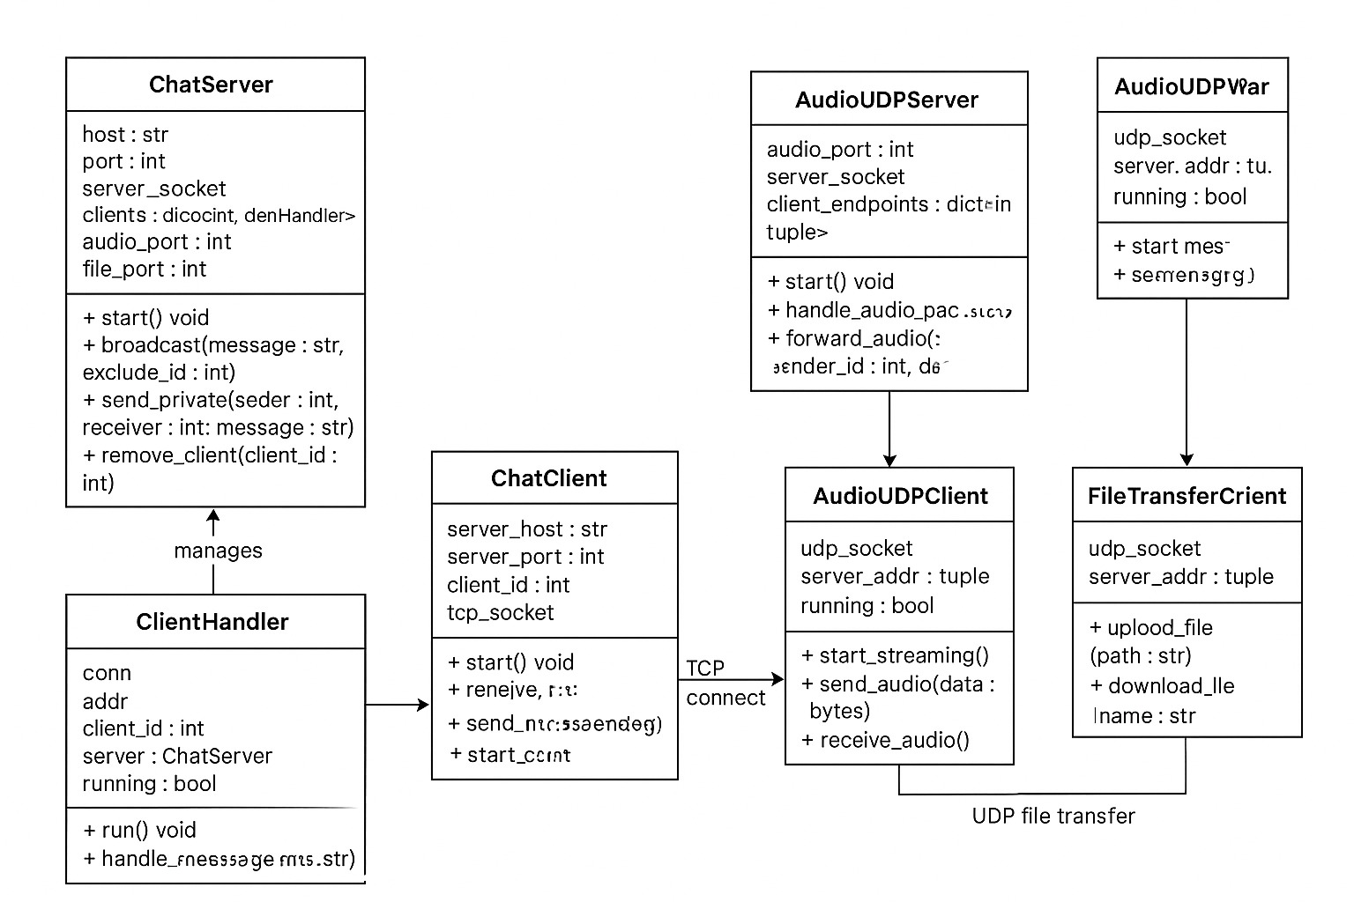
Output
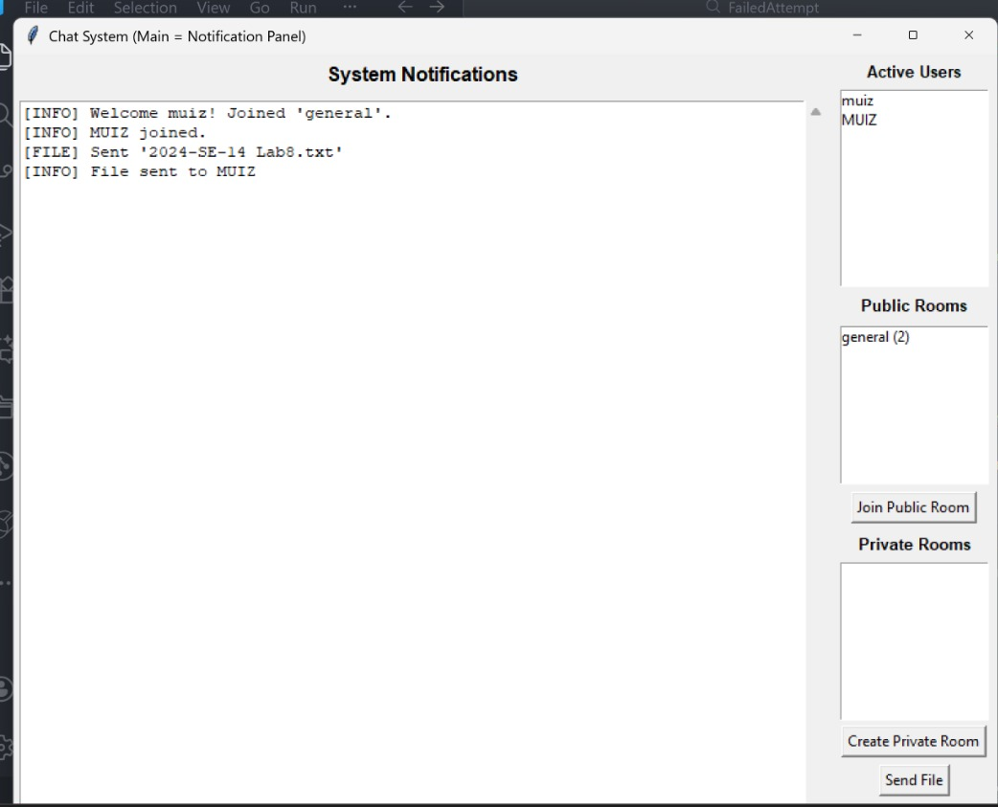

Error Handling

Connection Issues
- Automatic reconnection handling
- Graceful degradation when PyAudio unavailable
- Timeout management for file transfers

File Transfer Reliability
- Size validation before transfer
- Chunk-based transmission with error recovery
- Duplicate file prevention in download directory

Limitations & Known Issues
- Voice Calls: Requires PyAudio installation
- NAT Traversal: Direct P2P calls may not work across different networks
- Scalability: Single-threaded server may bottleneck with many users
- No Persistence: Messages and rooms not saved after server restart

Extension Possibilities
- Encryption: Add TLS/SSL for secure communication
- Database: Persistent message history and user accounts
- Media Support: Image/video sharing
- Mobile Client: Android/iOS applications
- Web Interface: Browser-based client

Conclusion
In conclusion, this chat application successfully demonstrates the implementation of a robust, multi-feature communication system that integrates real-time messaging, file sharing, and voice calling capabilities. Through its hybrid TCP/UDP architecture, the project showcases advanced networking concepts including reliable data transmission, peer-to-peer audio streaming, and concurrent client management. While serving as an excellent educational prototype for understanding network programming, thread synchronization, and real-time communication protocols, the application also provides a solid foundation that could be extended into a production-ready solution with additional security, persistence, and scalability enhancements.

